



Sarhad College of Arts, Commerce and Science

BSC Computer Science

Final Year Project

**Automatic Post Maker Using Web Scrapper**

**Sarhad News Post**

Submitted by

|  |  |
| --- | --- |
| **Ganesh Shivanand Gachchinmath** | **194031** |
| **Pratap Motiram Karhale** | **194039** |

Under the support and guidance of

**Ms. Sonali Gholve,**

**Ms. Trupti Taru,**

**Assistant Professor,**

**Department of Science**



Introduction: -

We have developed an automatic post maker with the help of web scraping integrated with web page Sarhad news post, we will scrap data from the news website such as Business Today and dump the headings into our personal website which we will be creating and convert that text into downloadable file in JPEG/PNG format. On our website their will, be templates already present and scrapped data will be dumped on that website only. We are using Web Scrapers it is closely related to web crawlers and while there are no real industry definitions for these terms, a distinction is often made, Web crawlers, or spiders or scrapers, are often used in search engines, as they crawl or scan through a website, looking for links, titles for indexing purposes. Web scrapers may still crawl through a website however a web scraper is a software that extracts data from webpages and stores the data in a database for further manipulation.

The project was made to solve a problem for content creators on regular basis on platform like Instagram, LinkedIn. Creators need to spare sometime to edit the post with the help of this project. Such a person will only have to select websites from which he had to scrap the data that’s it, then just with one click of download button we can save image in JPG/PNG file.

Aims and objective: -

The Project was made to solve a problem for content creators on regular basis on platforms like Instagram, LinkedIn, Facebook, WhatsApp need to spare sometimes to edit the post with the help of this project. Such a person will only have to select websites from which he had to scrap the data that’s it, then just with one click of download button we can save image in JPG/PNG file and then we can easily post them. However, it can be used as a tool for social media platforms. The focus of this project is to save your time.

The core aims of this project are:

* To build an understanding of content creators on the internet using web scrapers.
* To create a web scraper to crawl through and extract heading from news websites.
* To use Flask to develop light weight web app with inbuilt database.
* To Dump the headings in our template.
* To develop a web application to use as a front end and allow user to operate from back end through an intuitive interface.

The deliverables for this project are:

* Web Application
* Web Scraping
* Flask (light weight webapp) with inbuilt Database



Input Requirements: -

Business today News website for web scraping headlines.

Output: -

Data of input will be dumped in template after clicking download button we will be getting JPG/PNG file as an output.

Proposed System: -

* A PC that is connected to a network and can be used as a server to host the Application.
* Windows 10 Home Operating System

Software Requirements: -

* Visual Studio Code (VS-Code)
* Microsoft Edge Browser
* Python 3.10.0
* Extensions: Run Coder, Python intellisence, HTML, CSS Extension
* Frontend: HTML, CSS
* Backend: Python, JavaScript, Flask

Hardware Requirements: -

* Laptop with 8 GB RAM (For better Experience)
* 2 GB Space (HDD or SDD)
* WIFI or Hotspot Internet connection

Design: -

1. Use Case

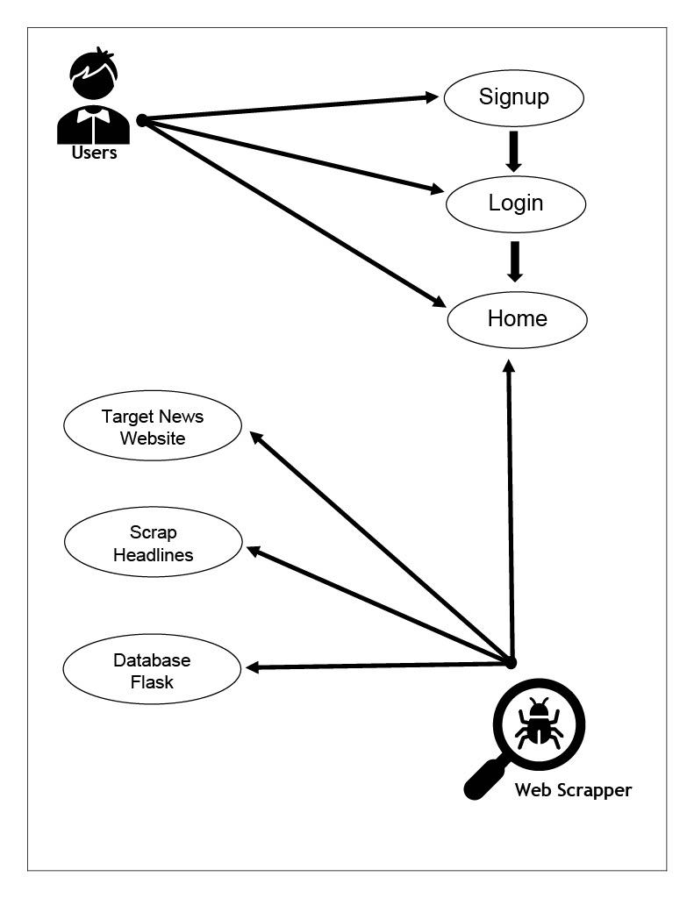

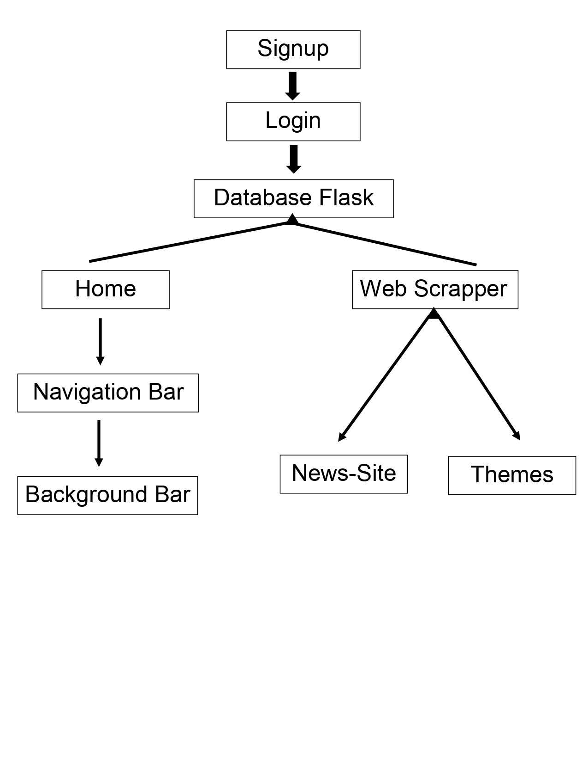2. Website Architecture: -

Users must first sign into the application before use, as the information this system deals with is sensitive. automatic post maker with the help of web scraping integrated with web page Sarhad news post, we will scrap data from the news website such as Business Today and dump the headings into our personal website which we will be creating and convert that text into downloadable file in JPEG/PNG format. On our website their will, be templates already present and scrapped data will be dumped on that website only. We are using Web Scrapers it is closely related to web crawlers and while there are no real industry definitions for these terms, a distinction is often made, Web crawlers, or spiders or scrapers, are often used in search engines, as they crawl or scan through a website, looking for links, titles for indexing purposes. Web scrapers may still crawl through a website however a web scraper is a software that extracts data from webpages and stores the data in a database for further manipulation

Database Architecture Design: -

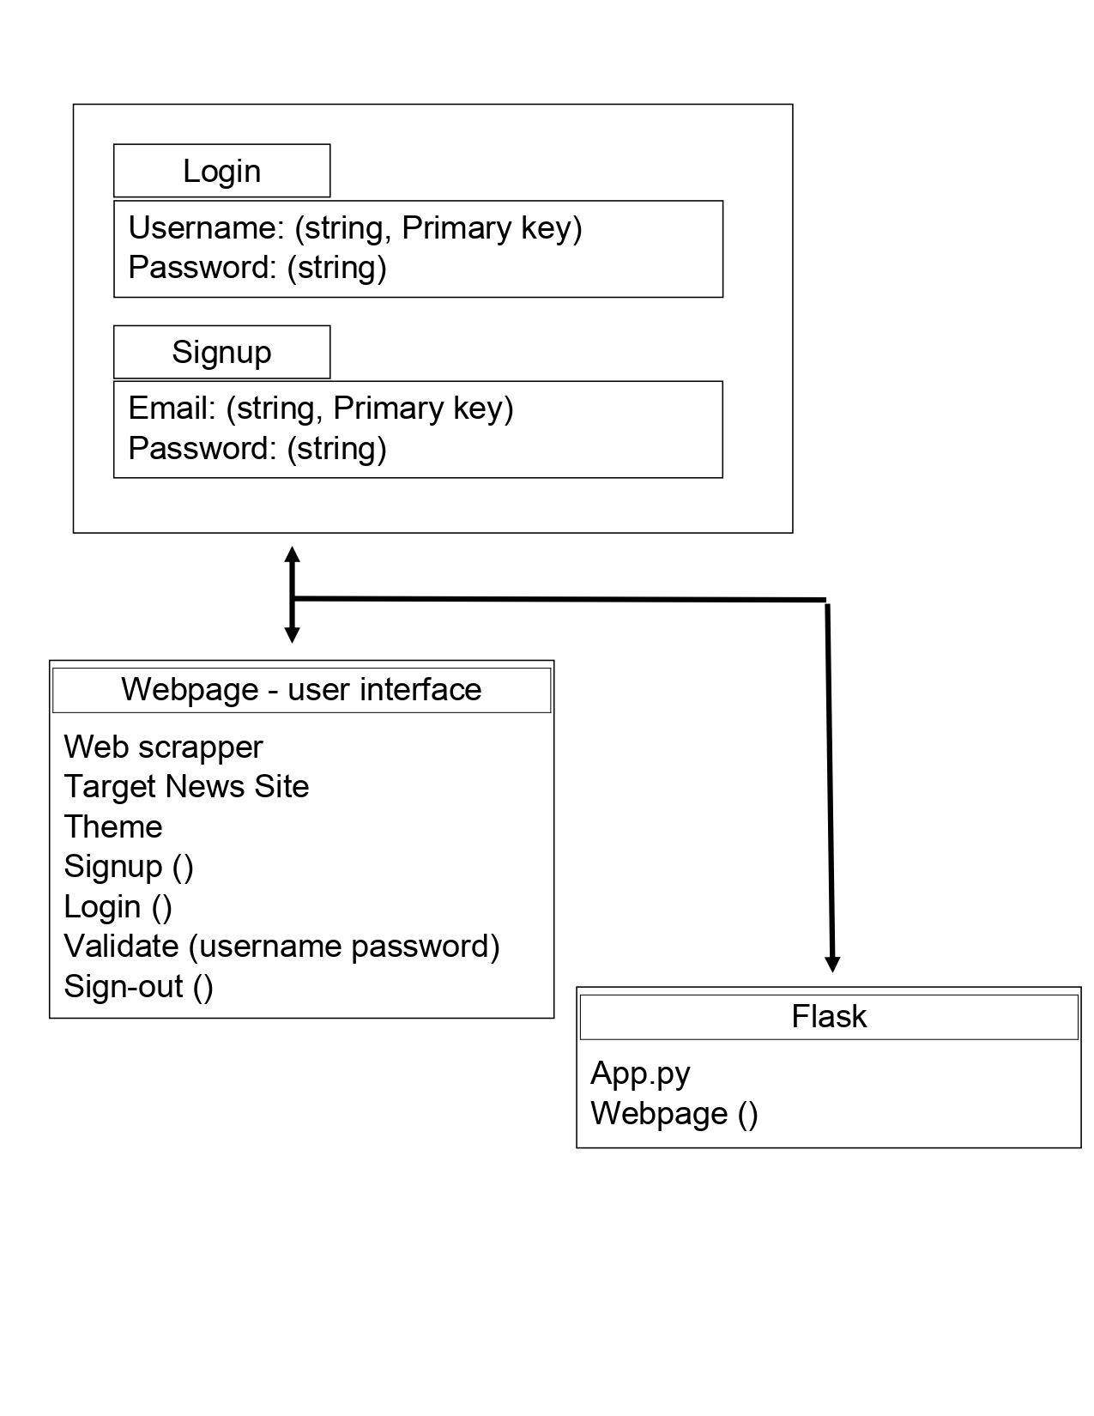



Database: -

Shown in above architecture figure is the database schema of the proposed system. In the database, there are three tables: Login/Signup, Webpage, Flask. These tables are enough to meet all the requirements of the application.

User contains the username, password and salt corresponding to a user to gain access to the application. The username is stored as text, however, the password is stored as a hashed value made up of the plaintext password and the salt, and is hashed using the SHA-256 hash function.

This is stored in the database because when a user attempts to sign in, the user-entered password is combined with the salt, hashed with the same SHA-256 hash function and compared to the stored password hash. This database schema is in third normal form (3NF), as there are no repeating groups, and each element in each table is dependent on the primary key of that table.

Web Application Image: -

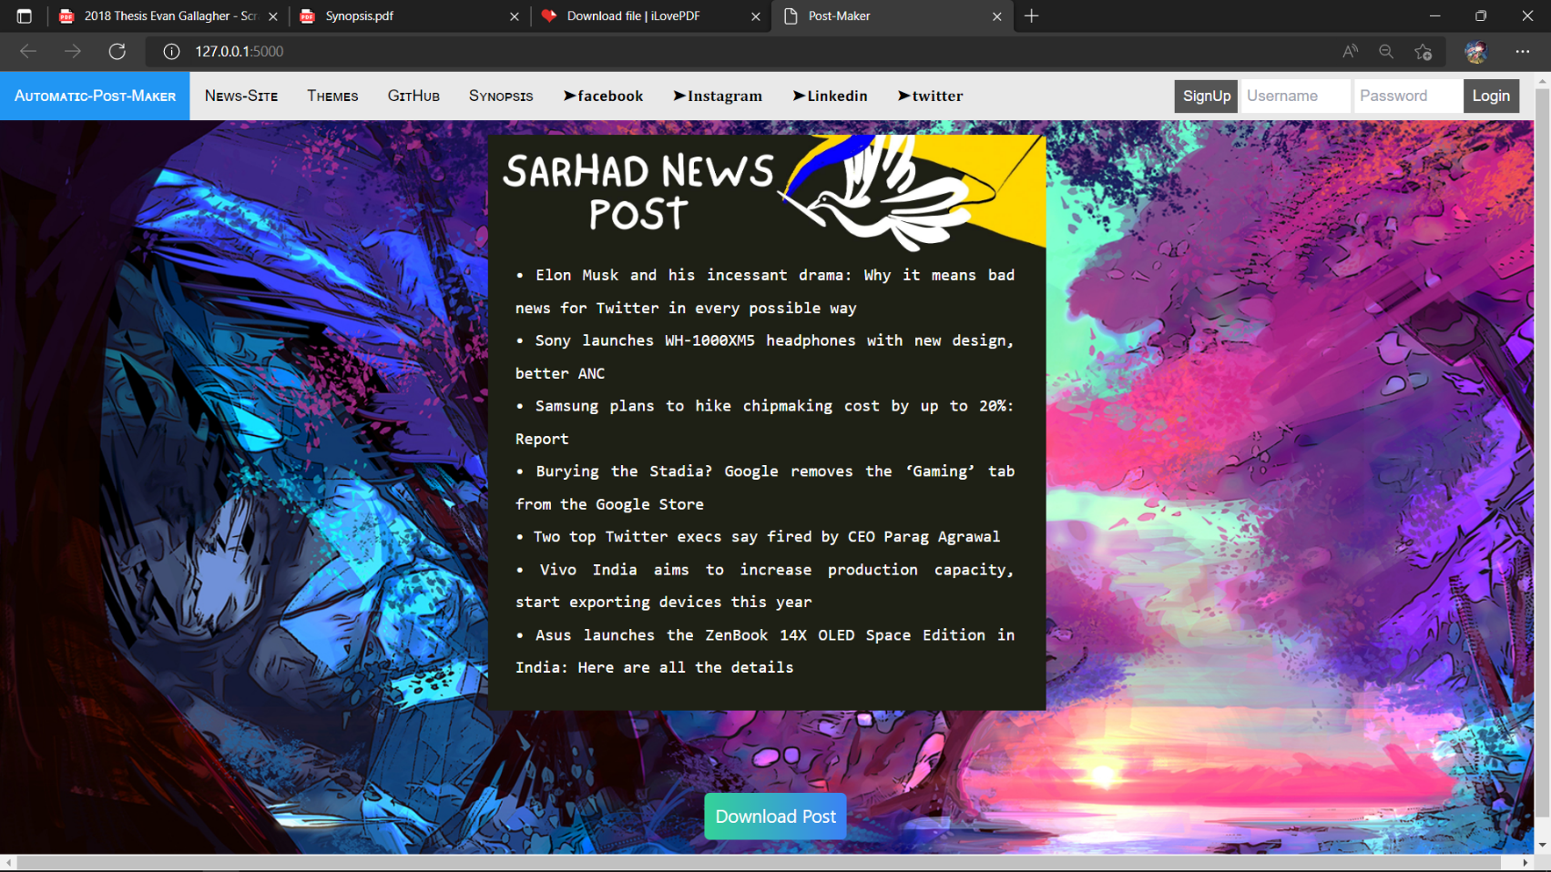

Signup/Login Page image: -

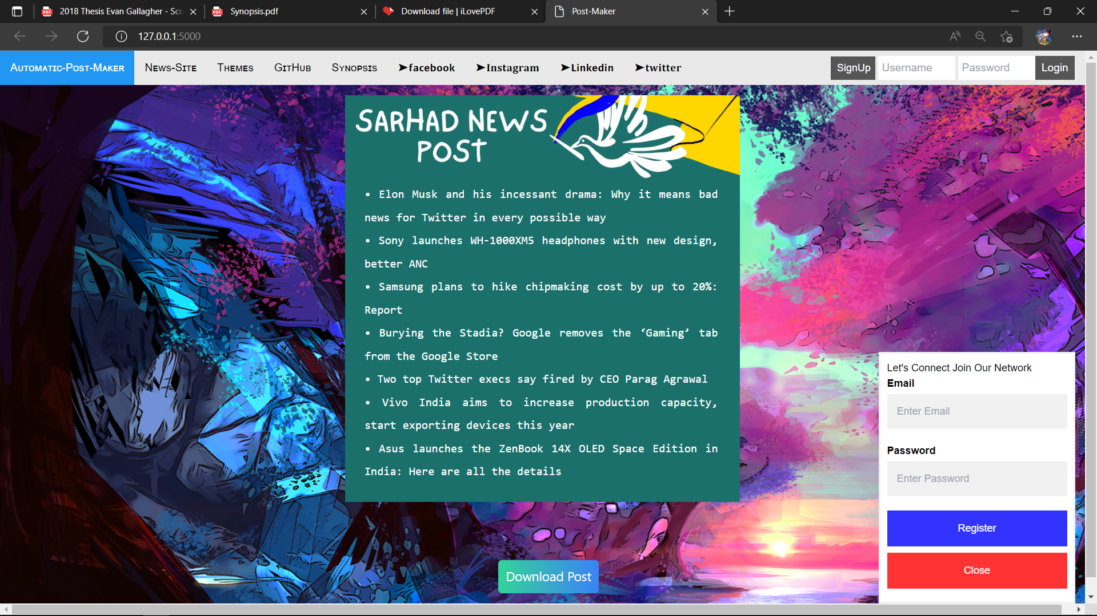



Web Application Image: -

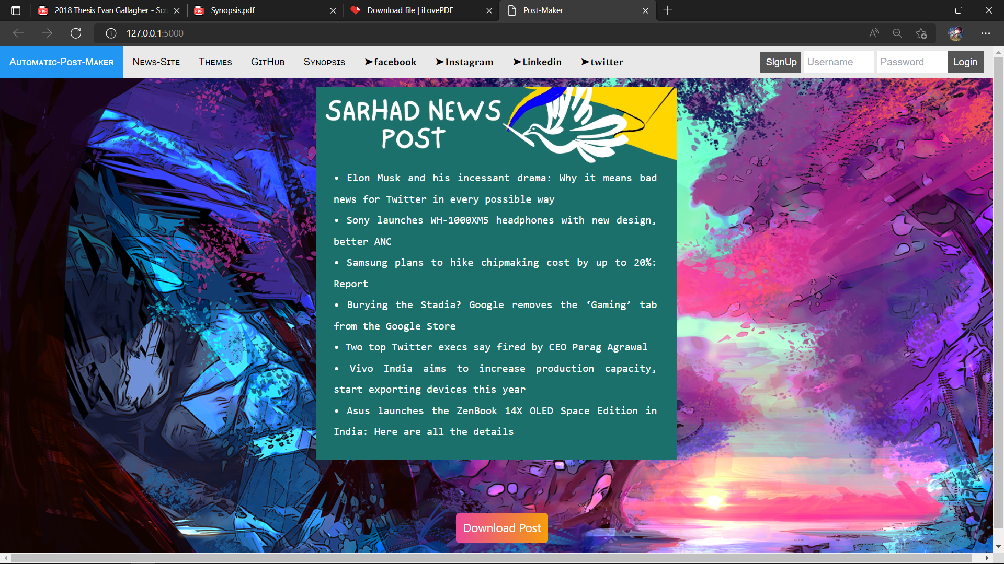

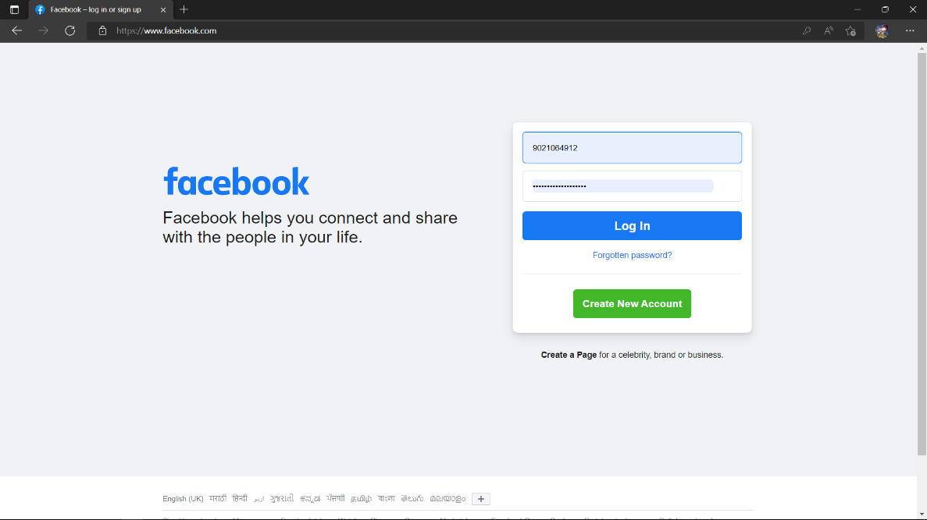Share post on social media using Navigation Bar: -

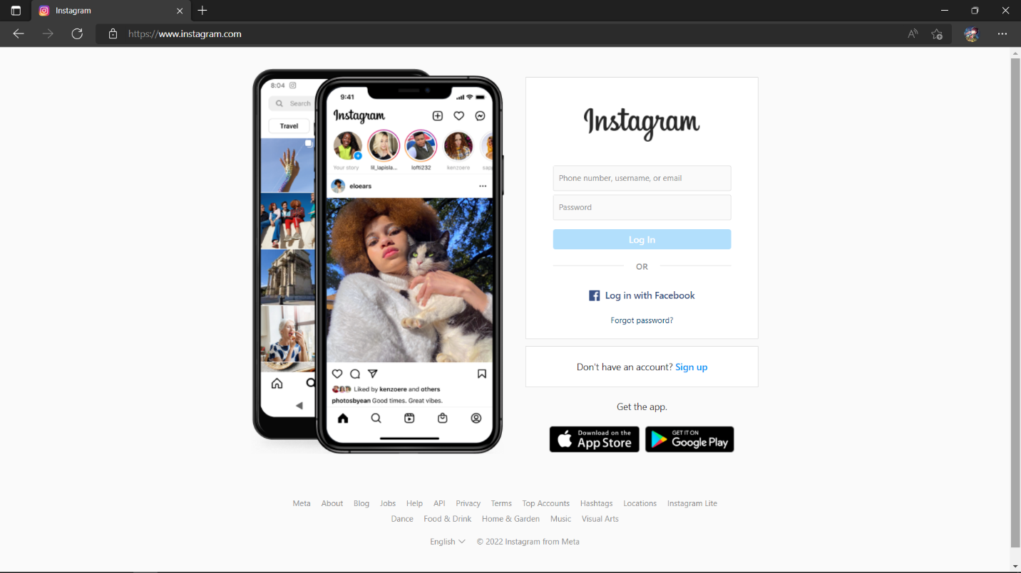

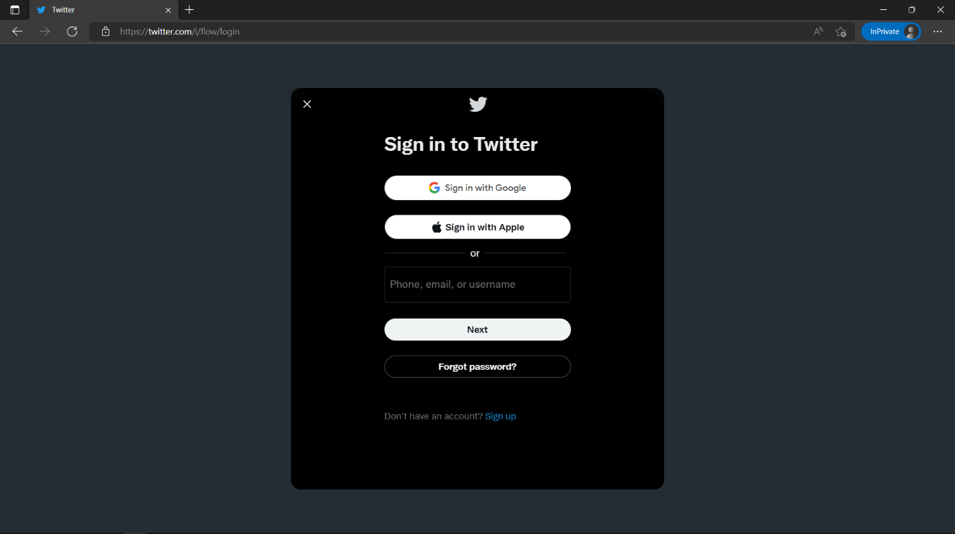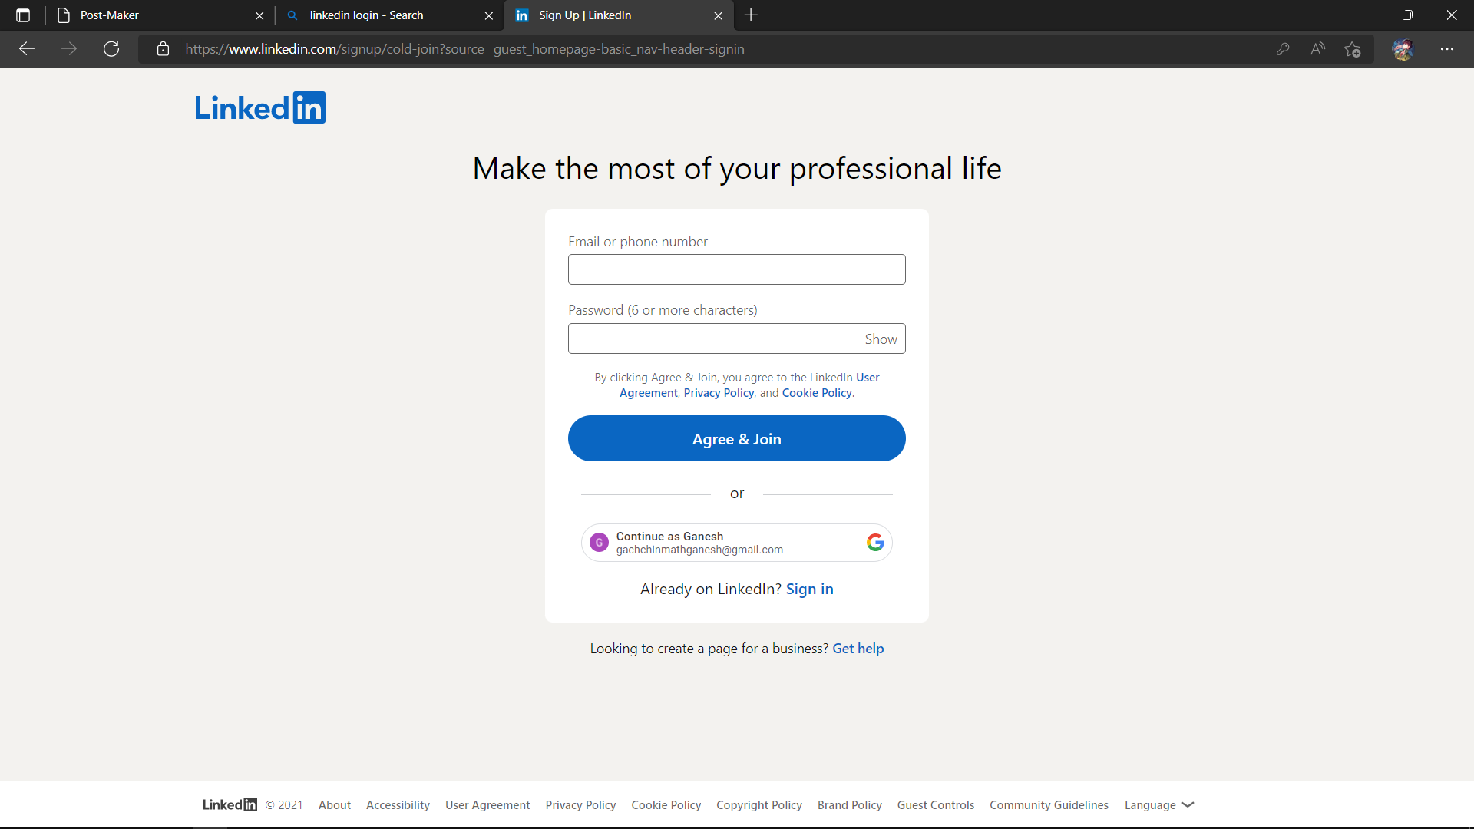

Targetted News-Site using Scrapper: -

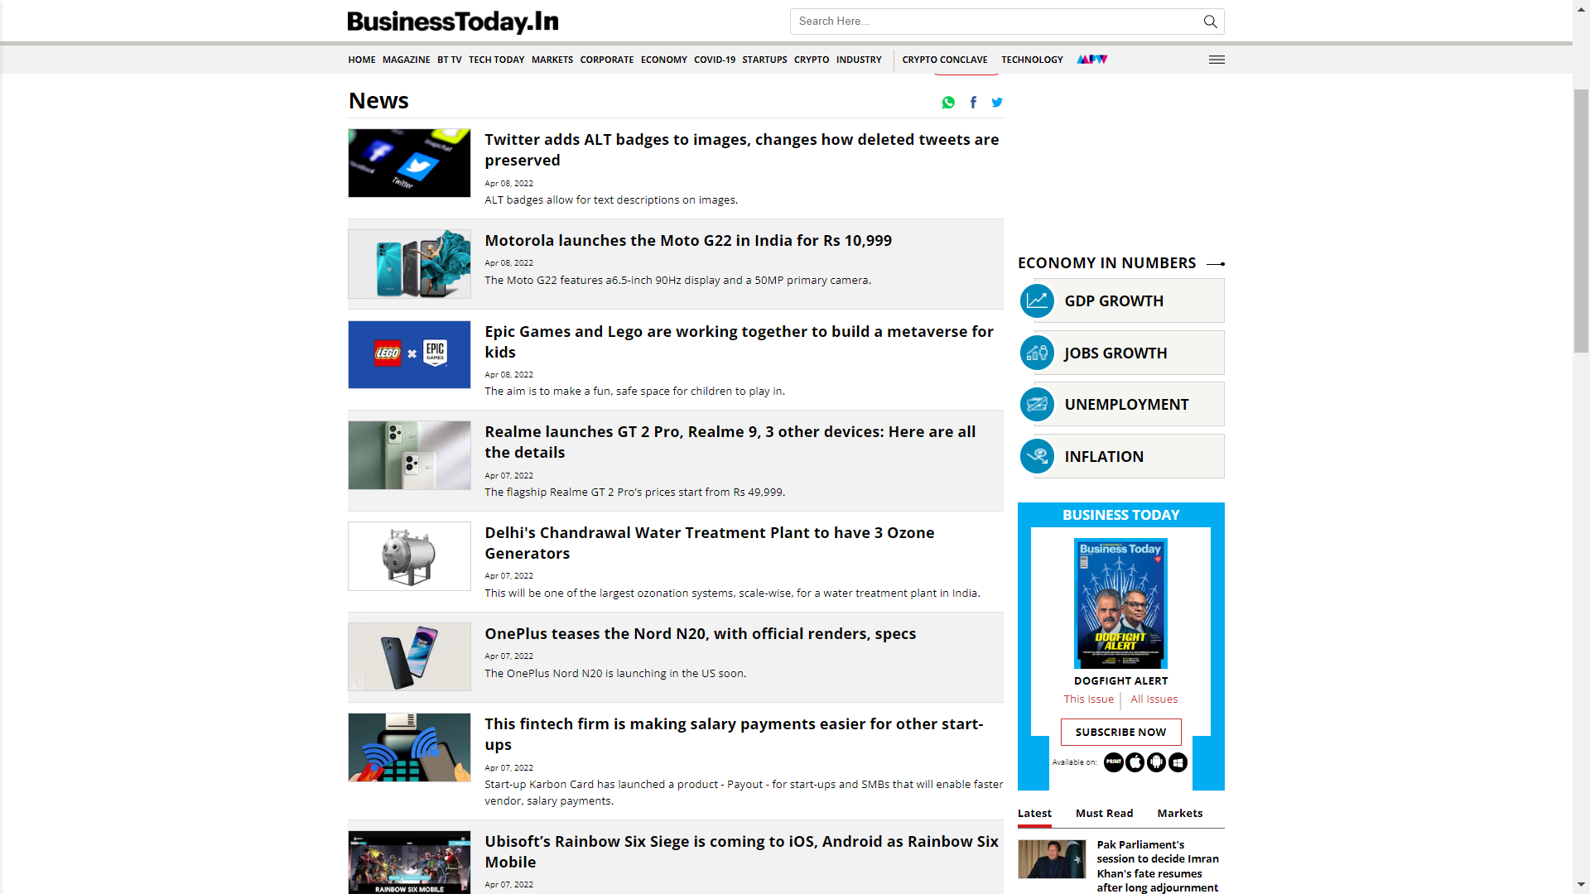

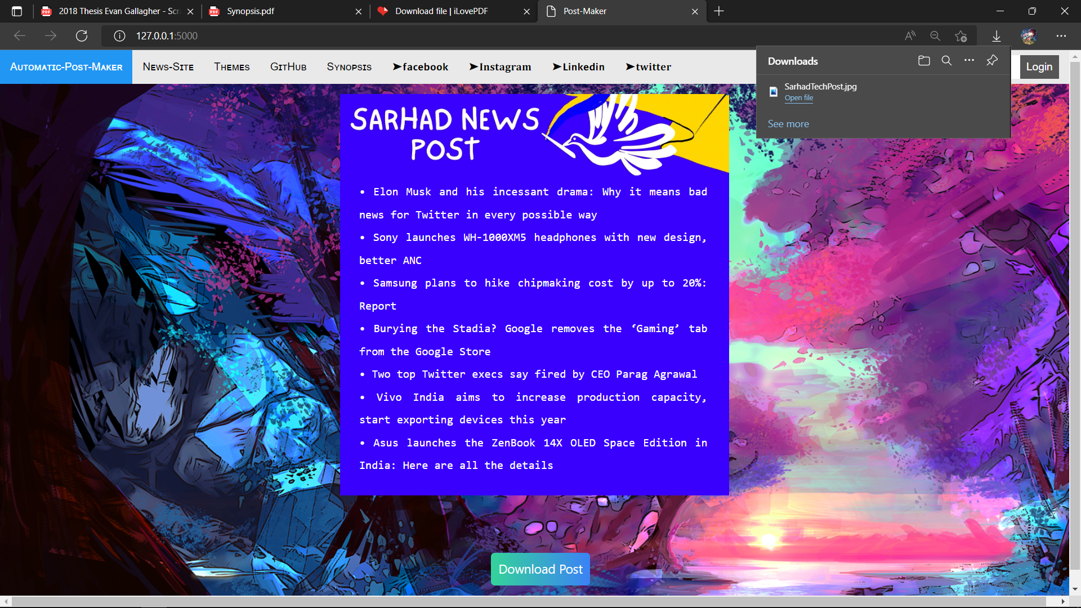We will scrap data from the news website such as Business Today and dump the headings into our personal website which we will be creating and convert that text into downloadable file in JPEG/PNG format.

Download Button: -

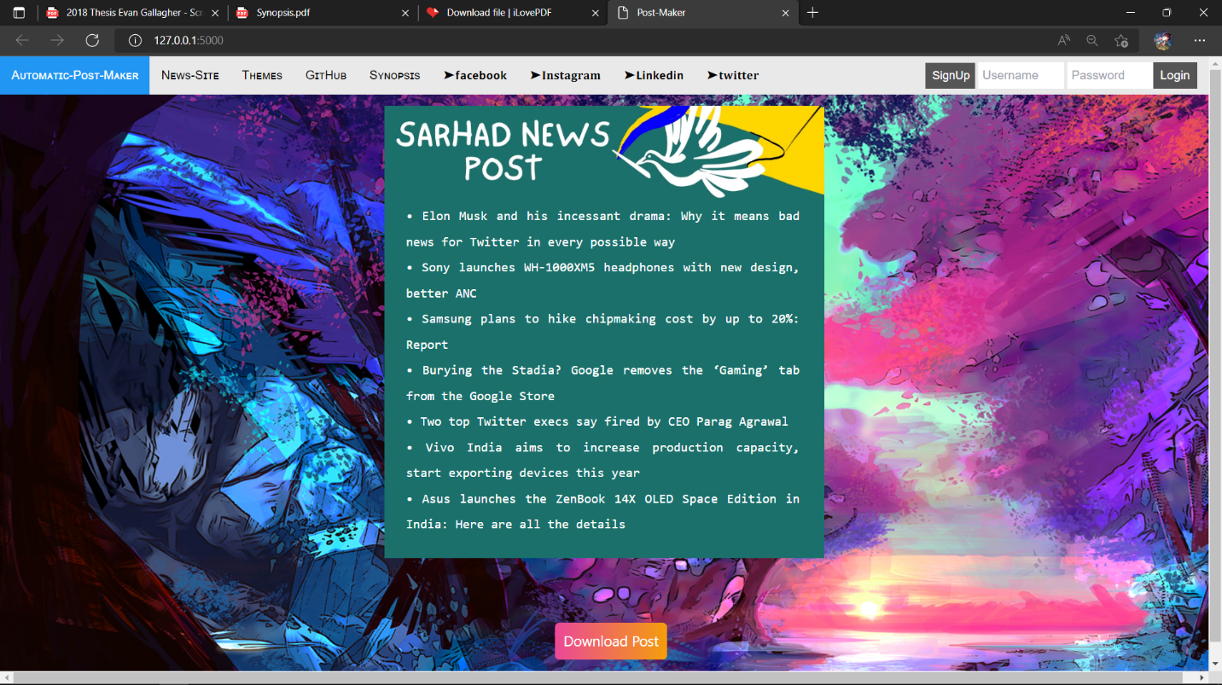



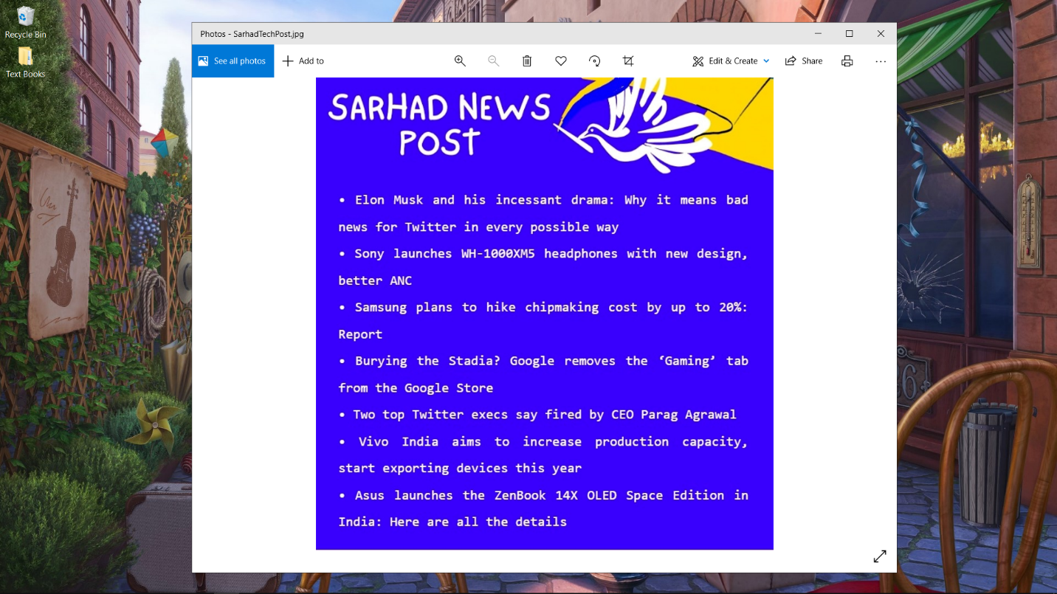

Sarhad news post, we will scrap data from the news website such as Business Today and dump the headings into our personal website which we will be creating and convert that text into downloadable file in JPEG/PNG format.

Templates For Post Maker: -

Select Themes From Navigation Bar after clicking on it templates are will change for every click.







References: -

Balodis, M. (2017) Web Scraper. Available at: http://webscraper.io/ (Accessed: 02/11/17).

Import.io (2017) Import.io | Extract data from the web. Available at: https://www.import.io/ (Accessed: 06/11/17).

Madhusudan, P.A. and Lambhate Poonam, D. (2017) Deep Web Crawling Efficiently using Dynamic Focused Web Crawler, International Research Journal of Engineering and Technology (IRJET), 04(06), pp. 3303

Mattmann, C. (2015) Search of the Deep and Dark Web via DARPA Memex (abstract).

Mitchell, R. (2015) Web scraping with Python: collecting data from the modern web. O'Reilly Media, Inc.

YouTube References: -

Web Scraping Tutorial using Python and Beautiful Soup <https://youtu.be/uufDGjTuq34>

Web Scraping with Python - Beautiful Soup Crash Course

<https://youtu.be/XVv6mJpFOb0>